ISMO Project Management System
Database Schema Documentation
This project uses PostgreSQL as the database provider, managed with Prisma ORM. Below is the documentation of the tables, relationships, and data models.

1. Database Relationships
• User owns Projects: One User can have multiple Projects (One-to-Many relation). If a User is deleted, all their Projects are deleted (Cascade Delete).
• Project contains Tasks: One Project can have multiple Tasks (One-to-Many relation). If a Project is deleted, all its Tasks are deleted (Cascade Delete).

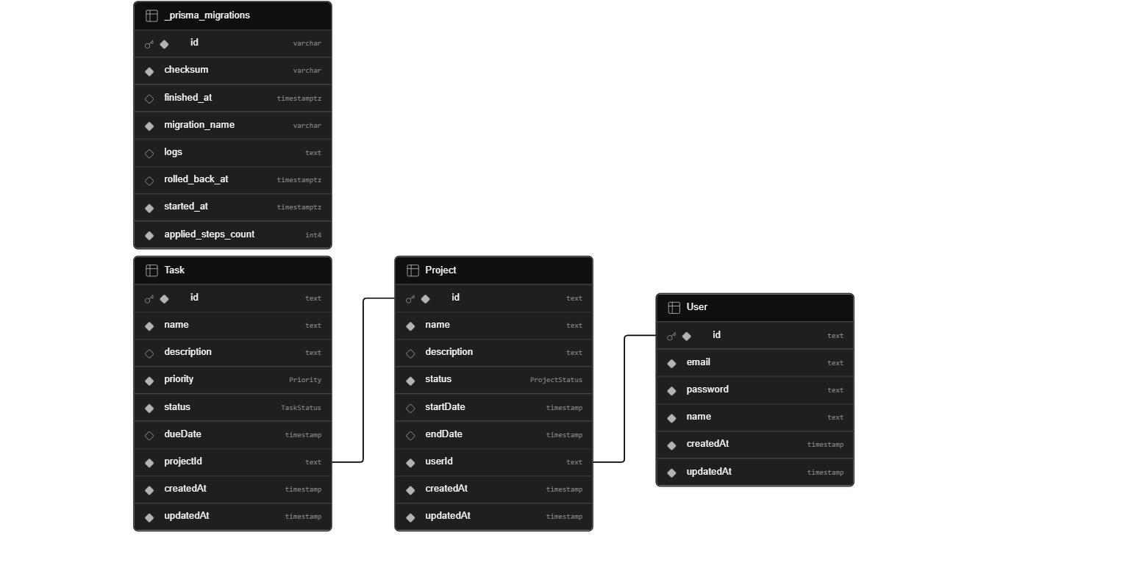

2. Data Models & Tables

User Table
Field | Type | Nullable | Description
id | String (UUID) | No (Primary Key) | Unique identifier generated automatically
email | String | No | Unique email address for registration/login
password | String | No | Bcrypt hashed password
name | String | No | User's full display name
createdAt | DateTime | No | Timestamp when the user account was created
updatedAt | DateTime | No | Timestamp when the user account was last updated

Project Table
Field | Type | Nullable | Description
id | String (UUID) | No (Primary Key) | Unique identifier generated automatically
name | String | No | The name of the project
description | String | Yes | Optional text detailing the project details
status | ProjectStatus (Enum) | No | NOT_STARTED, IN_PROGRESS, or COMPLETED
startDate | DateTime | Yes | Estimated start date of the project
endDate | DateTime | Yes | Estimated end date of the project
userId | String (UUID) | No (Foreign Key) | Reference to the User who owns this project
createdAt | DateTime | No | Timestamp when project was created
updatedAt | DateTime | No | Timestamp when project was last updated
Index | userId | - | Index created on userId for fast query performance

Task Table
Field | Type | Nullable | Description
id | String (UUID) | No (Primary Key) | Unique identifier generated automatically
name | String | No | The name of the task
description | String | Yes | Optional description details
priority | Priority (Enum) | No | LOW, MEDIUM, or HIGH
status | TaskStatus (Enum) | No | PENDING, IN_PROGRESS, or COMPLETED
dueDate | DateTime | Yes | Deadline date for task completion
projectId | String (UUID) | No (Foreign Key) | Reference to the Project containing this task
createdAt | DateTime | No | Timestamp when task was created
updatedAt | DateTime | No | Timestamp when task was last updated
Index | projectId | - | Index created on projectId for fast query performance

3. Database Enumerations (Enums)
Enum Name | Allowed Values
ProjectStatus | NOT_STARTED, IN_PROGRESS, COMPLETED
Priority | LOW, MEDIUM, HIGH
TaskStatus | PENDING, IN_PROGRESS, COMPLETED

